Hitting Outline:

1.0 General
It has been said that hitting a baseball well is the single most difficult sports skill to master. Even in the pro's, the best hitters only get a hit 3 out of every 10 at bats.
One definite thing about hitting is that to do it well requires knowing the proper mechanics involved
and to
practice, practice, practice, practice
and then
PRACTICE
some more!
Some general principals of hitting are to:
Study the pitcher (get a feel for his/her speed, does he have curve/change-up, does he do anything different when he throws it, etc.).
Keep your eyes on the ball through contact. Know the strike zone and get a good pitch to hit.
- Know the situation (count, score, runners, outs) and what it calls for.
- Be aggressive, the hitter should load and stride (more on this later)on every pitch and be up there thinking hit, hit, hit, so that he/she is ready to explode with the hips and hands if it is a strike.
- If the pitch is not a strike don't swing.
- Have no fear
2.0 Bat Selection - Size / Weight

Summary
2a. Batter should swing what length/weight is comfortable
2b. Error on side of lighter rather than heavier

Proper bat selection is a key part of the hitting procedure. As a young ball player or even a pro, the single most factor that will affect your hitting quality will rely on how comfortable you are swinging the bat. With that in mind:
1.You should always choose a bat that you can handle quite easily. One that you feel comfortable swinging and does not slow you down at all.
2.Bigger players use bigger bats, smaller players use smaller bats!!! You don't see Rickey Henderson going to the plate with Mark McGwire's bat!!!
The bat you use should be proportional to your size, weight, agility, and power.
A good test to determine if a bat is too heavy is to grab the handle of the bat with one hand and hold it straight out to the side, parallel to the ground. If it starts to shake or the bat head starts to drop in less then 12-20 seconds, then the bat is too big.
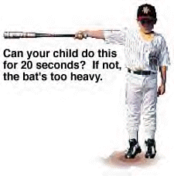
Most boys in the 9-14 age range do best with the 20-24 ounce bat.
Use the charts below as a general guideline for determining BAT LENGTH.

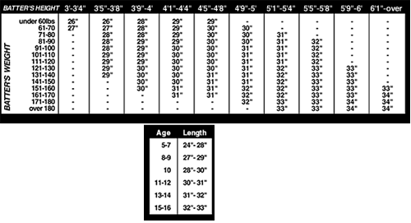

Use the charts below as a general guideline for determining BAT WEIGHT.
Little League (8-10 yrs)
Player Height | Bat Weight
48-50" | 16-17 oz.
51-54" | 17-18 oz.
55-59" | 18-19 oz.
60+" | 19-20 oz.

Youth League (11-12 yrs)
Player Weight | Bat Weight
70-80 lbs. | 18-19 oz.
81-100 lbs. | 19-20 oz.
101-120 lbs. | 20-21 oz.
121-140 lbs. | 21-22 oz.
141+ lbs. | 22-23 oz.

High School & College
Player Height | Bat Weight
66-68" | 27-28 oz.
69-72" | 28-29 oz.
73-76" | 29-30 oz.
77+" | 30-31 oz.

*** Baseball Bat Types ***
- Tee-Ball Bats
Tee-Ball bats are for ages approx 5 thru 7. They are generally used in tee-ball and coach pitch leagues. The bat barrel is 2 1/4 inch in diameter. Bat lengths range from 25 inch to 27 inch. Bat weight is measured in weight drop, which varies between brands and models. Heavier bats are around minus 7 weight drop, lighter bats are around minus 13.
- Little League Bats
Little League bats are for ages approx 7 thru 12. They are used in leagues including Little League, Babe Ruth, Dixie Youth, PONY, and AABC. The bat barrel is 2 1/4 inch in diameter. Bat lengths range from 28 inch to 32 inch. Bat weight is measured in weight drop, which varies between brands and models. Heavier bats are around minus 7 weight drop, lighter bats are around minus 13.
- Senior League Bats
Senior League bats are for ages approx 10 thru 13. They are used in certain travel and tournament leagues. The bat barrel is available in 2 5/8 inch (high school regulation), and 2 3/4 inch (Big Barrel). Bat lengths range from 28 inch to 32 inch. Bat weight is measured in weight drop, which varies between brands and models. Heavier bats are around minus 5 weight drop, lighter bats are around minus 11.
- High School / College Bats
High School / College bats are for ages approx 13 and up. They are used in most High School and College leagues. The bat barrel is 2 5/8 inch in diameter. Bat lengths range from 30 inch to 34 inch. Bat weight is measured in weight drop, which must be minus 3. Most leagues require an approved BESR stamp on the bat (Bat Exit Speed Rating).

3.0 Grip

Summary
3a. Line up the knuckles
3b. Loose grip

The grip on the bat should be comfortable in the hand, ideally the middle knuckles on each hand would line up. This helps in executing the proper swing. The grip should be fairly loose up until you 'load' particularly with your top hand. Don't choke the bat with such a tight grip that it tenses up all the muscles in your arms and shoulders.
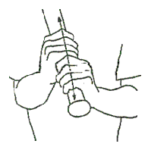


4.0 Stance

Summary
4a. Location of Feet
4aa. Closed, Open, Square (recommended) stances
4ab. Feet a little more than shoulder width apart
4b. Position in the box
4ba. Front to back location
4bb. Distance from the plate (plate coverage)
4c. Body
4ca. Balanced – Weight centered on feet (Athlectic position)
4cb. Knees slightly bent
4cc. Body straight
4d. Hand Location
4da. Approximately top of shoulder
4db. 5 – 7 inches from body
4e. Arms (relaxed)
4f. Bat location (head of bat pointed up)

The term "batting stance" refers to the position of the body and bat while awaiting a pitch.
Step into the batter's box with your body facing home plate. Usually for younger players the Parallel or Squared stance is recommended. This means that the batter has both feet equal distance from home plate.
The batter's feet should start a little more then shoulder width apart.
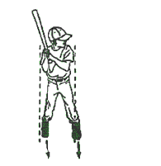
The batter should be close enough to the plate that he can comfortably reach down and touch the outside edge of the plate with his bat. This will insure that he can reach the outside pitch as well.
At this point weight should be equally balanced between the front and back legs.
- Both hips and shoulders should be parallel to the ground.
- Batter should have a slight bend in the knees.
- Hands should be just off the back shoulder with the bat angled at about 45 degrees.
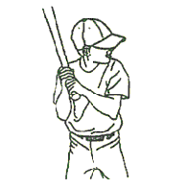
Bat & Body Position
Let comfort dictate your choice, but the bat should be no less than 5 inches and no more than 7 inches from your torso.
Holding your hands near your body keeps you on the inside of the ball. If you hold the bat out farther than that, your swing has too large an arc; you'll lose leverage and find it difficult to coordinate your hip and arm into your swing.
If you bring the bat in too close, you restrict your movement and lose bat speed; your swing has a large loop, and it requires a long push to get your bat into the hitting zone. By the time you get the bat where you need it, that fastball is already past you.
(see below)
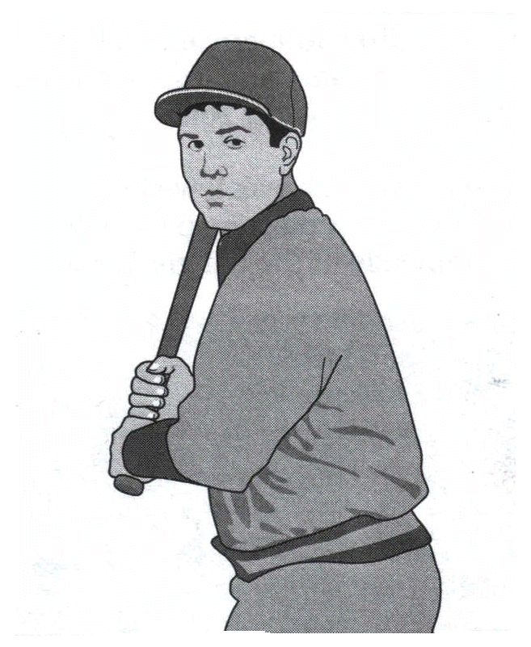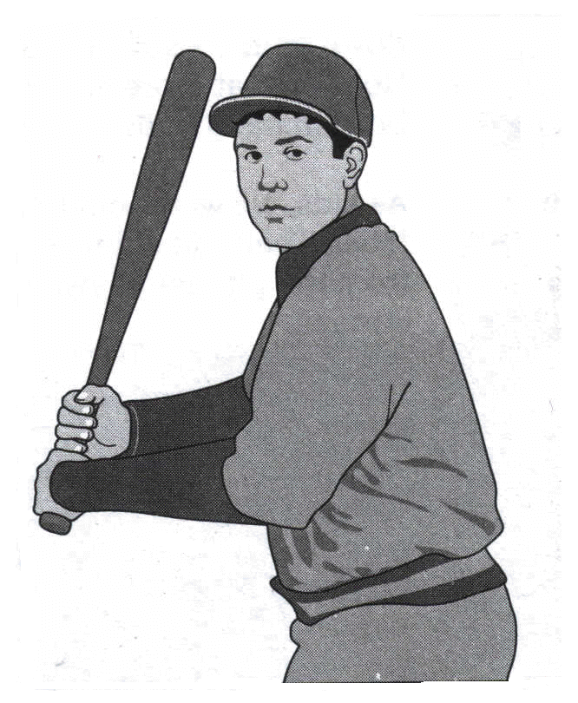
Hold your hands somewhere between the letters on your uniform front and your shoulders.
Your elbows should be away from your body
(as shown below).
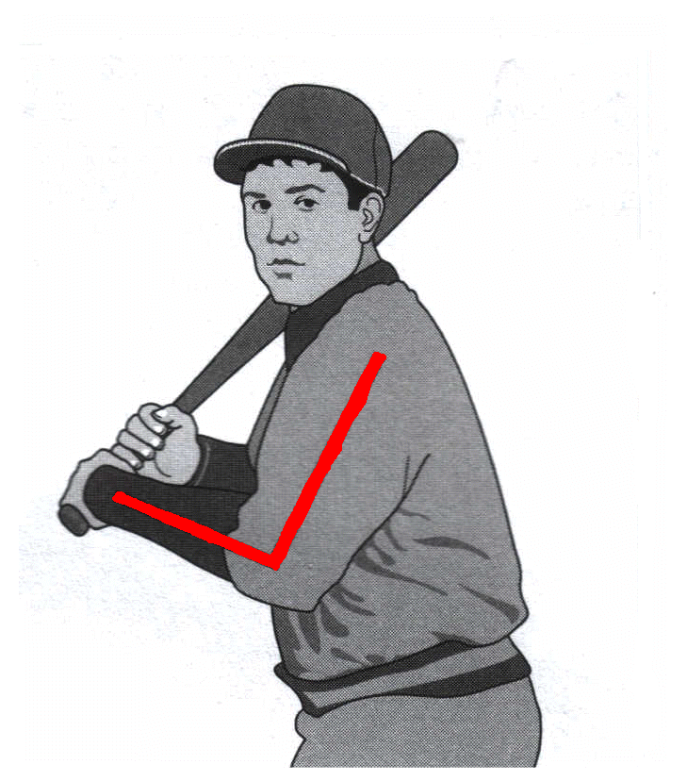
Taking Your Stance in the Batter's Box
When you come up to home plate to hit in the game of baseball, the first thing you must decide is where to stand in the batter's box. This is a matter of personal preference, and any number of combinations is possible. To discover what serves you best, hit from various positions in the box against live pitching.
The benefits of being up front
When you stand at the front of the box (see below), your stride brings you in front of home plate. Anything you hit in front of the plate has a better chance of staying fair. Standing in front also helps you against sinkerball and breaking ball pitchers; you can hit the ball before it drops below your swing.
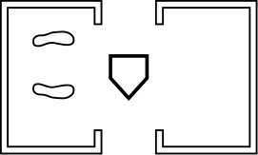
Standing at the front of the box also enables you to hit the curveball before it fully breaks. Even knuckleballs are easier to hit from this location; they have less time to dance.
Fastballs provide your up-front stance with its ultimate test. The closer you are to the pitching mound, the faster pitches reach you at the plate. If you can't handle fastballs from the front of the batter's box, you need to step back.
To develop bat speed and strength, Joe Morgan swung a lead bat only with his front (right) arm. This exercise strengthens your front side, which pulls the bat through the hitting zone. He did this 50 times a day during the off-season and 10 times before a game. Your daily regimen should also include 25 full swings with a bat that's heavier than the one you normally use in a game.

Stuck in the middle
Some batters take their swing from the middle of the box (see below). Hitting from the middle gives you a little more time to catch up with the fastball — but curveballs, sinkers, and knucklers also have more time to break. If you have only medium bat speed (something a coach can tell you), this is the place for you (at least until you develop a faster bat).
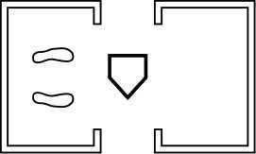
Tales from the deep
Obviously, standing deep in the box allows you the maximum time to cope with the fastball. But you have to be a great breaking ball hitter to consistently succeed in this location; you're giving the curve, sinker, and knuckler their best opportunity to work their magic.
Because you'll be hitting balls on the plate and the angle of your bat is toward foul territory, their trajectory may carry more of them into foul territory. If you stand deep in the box and far from the plate, you may find it difficult to hit outside pitches (see below).
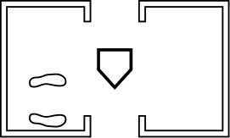

Positioning your body
The knees must be slightly bent. The amount of bend in the knees can vary according to the batter's preference.
The hitter should be positioned so that there is a slight bend at the waist.
The toughest pitch to hit is the ball out and away from you. After getting in the batter's box, swing your bat to make sure you have full plate coverage. Stand close enough to home to reach pitches 4 inches off the outside corner.
When you're close to the plate, the outside part of it becomes your middle, and you take away strength from the pitcher. Sure, the pitcher can throw even farther outside, but if you're a disciplined batter you can take those pitches for balls.
Hitters can choose from three basic stances:
·The open stance: Your back foot is closer to the plate than your front foot.
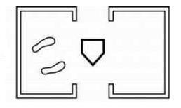
·The even or square stance: Both feet are equal distant from the plate.
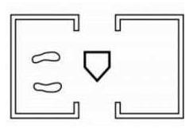
·The closed stance: Your front foot is closer to the plate than your back foot.
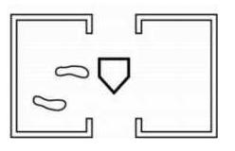
Only hitters who can't rotate their hips out of the way properly need a somewhat open stance. (Your coach can tell you whether you have the right hip action.)
Here are the two reasons why:
·The open stance frees your upper torso and automatically opens your hips, allowing you to drive your body and hands through the hitting zone while generating bat speed.
·The open stance also lets you turn your head so that it faces the pitcher, which enables you to use both eyes simultaneously.
Everybody rotates away from the ball in order to hit. Open-stance hitters are already a half step away from the plate. They must, therefore, remind themselves not to pull off the pitch or they won't be able to hit the ball with any authority.
For that reason, most major leaguers choose the closed stance or square stance.
Novice hitters should start with an even stance. It helps you keep your weight distributed evenly on the balls of both feet. (Now you know how the stance got its name.) As you gradually develop balance, reduce your stance an inch at a time until you find the closed stance that generates the most power.
Your shoulders are slightly closed in a closed stance and more squared in the even or open versions. No matter which stance you choose, point your face toward the pitcher's mound so that you can see the pitcher with both eyes.
Young hitters often make the mistake of looking out of only one eye. Sometimes they slightly cock their heads to the side so that one eye is closer to the pitcher than the other. This stance alters your depth perception. You need both eyes on a parallel plane if you are going to read the ball's spin and speed as quickly as possible. Tucking your chin behind your shoulder also limits your vision.
Keep your head square and still throughout your stride and swing. You may hear broadcasters discuss how a hitter keeps his head down throughout his swing. That's always good policy. Keeping your head down keeps your eyes on the ball. Move your head, and your body follows - and your swing suffers.
When taking your stance, bend your knees slightly to allow greater freedom of movement. An erect stance restricts your lower body's maneuverability. How far you spread your legs apart is a matter of personal preference.
(see below).
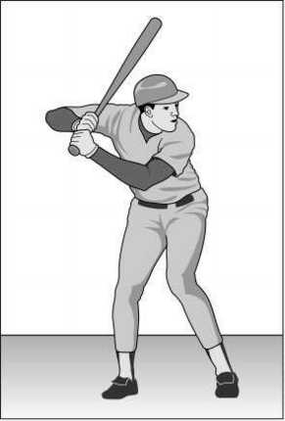
"Batting stances vary widely, and all players develop their own styles. Combine these basic elements with what feels comfortable for you."

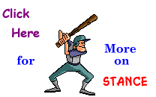
5.0 Load and Stride

Summary
5a. Load
5aa. Go back to Go Forward
5ab. Weight shift
5b. Stride
5ba. Short in length (2 -3 inches) and height
5bb. 45 degree angle toward plate
5bc. Land front foot softly (stepping on an egg)
5bd. Land on inside of front foot or big toe
5be. Complete before swing and before pitch gets to home plate
Loading Phase
Many young hitters swing the bat after the ball is past them, and many times this happens because they don't get into the load position in time. Load position refers to the position that the body and bat need to be in just prior to the swing. The loading phase refers to striding and the positioning of the bat. This phase is important because, if done properly, it can help the hitter make solid contact with the baseball on a more consistent basis.
Once the pitcher begins his movement forward with the pitch, the batter should then 'load'. What this involves is a slight movement inward and backwards (about 2 inches) of the batters hands, shoulders, hips and knees. The batter's weight shifts from a 50/50 to a 40/60 front to back ratio. During this load it is important to not move the head and to keep your eyes on the ball.
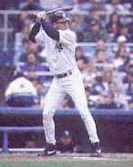 | Derek Jeter right after loading.
Notice how weight is about 40/60.
The stride consists of a short (5-7 inches) step with the front foot either directly towards the pitcher or at a slight angle towards home plate. You want to lead with heel and land on the ball of your foot. You still want to keep your front shoulder in and your hands and weight back during your stride. Picture it as stepping on thin ice. It is important to not swing until your front foot has landed, as you want to hit against a firm front leg.
Striding
Stride refers to the movement of the front foot during the loading phase.
Around the time that the pitcher lifts the knee, the batter should lift the front knee up and back towards the catcher (Knee height varies from hitter to hitter). The body weight should be shifted towards the back leg.
- About the time that the pitcher releases the ball, the batter should be striding towards the pitcher and transferring the body weight forward.
- The stride of the front foot needs to be short in length, no longer than 6 inches.
- The hitter should have the stride foot (front foot) down well before the ball gets to homeplate.

Four Keys to a Correct Stride
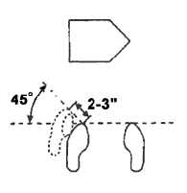 | 1.The batters stride should be short, no more than two or three inches.  2.The stride should be at a 45 degree angle towards home plate.  3.The batter should land softly on his front foot as if he were stepping on an egg.  4.The batter should stride and land on the big toe or inside of his front foot.
LEARN MORE

6.0 Swing

Summary
6a. Contact ball on the barrel (sweet spot)
6b. Pick up pitch from release point
6c. Pick up spin of baseball (determine type of pitch)
6d. Extend arms at contact
6e. Level swing
6f. Rotate hips during swing – (3 eyeballs)
6g. Eyes follow ball to contact with bat
6h. Keep head level during swing
6i. Keep head/eyes @ contact are until follow through is complete
6j. Contact area
6ja. Just in front of home plate
6jb. Inside pitch farther out
6jc. Outside pitch farther back

Getting The Barrel To The Ball
The batter should swing the barrel of the bat directly at the ball and should try to hit the ball with the sweet spot on the bat. The sweet spot is generally the area between 2 and 6 inches from the top end of the bat.
The batter's arms should be extended right before contact is made with the baseball.
- The bat should be on the same plane as the baseball when contact is made.
Turning The Hips
If lower body strength and bat speed are to be maximized, it is essential that the hips be turned during the swing.
In order to turn the hips during the swing, the hitter should pivot on the ball of the back foot.
Keeping The Eyes On The Ball
Hitters should keep their eyes on the baseball until contact is made.
The hitter's head should not follow the body when it turns.
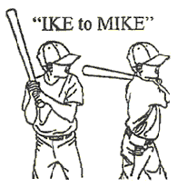 | The batter should turn his head enough that he can see the ball with both eyes. The "IKE to MIKE" method should be taught. The batter,s front shoulder, toward the pitcher, is "IKE", and his back shoulder is "MIKE". The batter should start with his chin on "IKE". During the swing the head does not move. The body rotates and the shoulders switch places with the head finishing on "MIKE". The batter should keep his eyes on the ball and should be taught to "track" the ball from the pitcher's hand to the bat.
After the batter has completed his load and stride, and upon picking up the pitchers release point and picking up the ball and has concluded that the pitch coming at him is a strike, the batter then initiates his swing. The swing involves rotating up on the ball of your back foot (this is known as squishing the bug). The hips begin to rotate and the hands (bat knob) go towards the ball (As shown below in this Derek Jeter Photo)
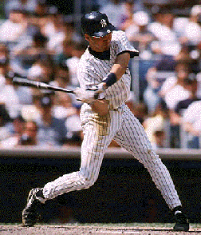You want to avoid an upper cut swing by swinging down on the ball. As you start your swing you'll want to keep your hands above the ball and the fat part of the bat above your hands. Your head should remain still with your chin going from your front shoulder to your back shoulder when finished with your swing. At time of contact you want to have your bottom hand palm facing down and your top hand palm facing up. This will increase the chances of a line drive, which provides you with the best chance of reaching base. As you come in contact with the ball your arms will form a V with the bat to which you should be looking down through to the ball hitting the bat. Swing through the ball as if you're hitting more than one ball and follow through after contact.
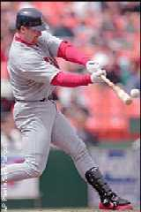 | Mark McGwire's swing.  Notice the stiff front leg.  Hands above the ball.  Bottom hand palm down, top hand palm up.  Eyes looking at ball down the V formed by the arms.  Chin near back shoulder.
LEARN MORE

7.0 Follow Through

Summary
7a. Swing through the ball
7b. One hand vs. Two hand finish (either ok but one hand runs risk of releasing too early, need to make sure both hands are on the bat at contact)

Following Through
After contact is made with the ball, the barrel of the bat should maintain a smooth, slightly upward path, which ends with the hands rolling over.
The handle of the bat should stop around the left shoulder for a right-handed batter and around the right shoulder for a left-handed batter.
- The barrel of the bat should wrap around the upper back.
- The hitter's chin should be over the shoulder area at the completion of the swing.
8.0 Bunting

Summary
8a. Two approaches
8aa. Pivot
8ab. Turn Body
8b. Slide hand up
8c. “Catch” ball with bat
8d. Sacrifice vs. base hit bunt

Bunting has become a lost art. At each level up the ladder, runs become harder and harder to generate and sometimes teams must 'manufacture' runs. Bunting is a great tool in manufacturing runs. Sometimes you may want to bunt for a hit, sacrifice a runner over into scoring position or 'squeeze' a run in through bunting. When bunting, you will want to move up in the batter's box towards the pitcher. This will keep your bat in fair territory and also assist you in bunting any breaking balls before they break. Generally when bunting for either a sacrifice or Squeeze lay you will want to square around. This means turning your feet and shoulders so that you are facing the pitcher. Don't step on the plate or you'll be called out if you get the bunt down. The top hand should slide down the bat somewhere around the mid point and 'cradle the bat' with your thumb on the top with the fingers underneath. To protect your fingers from getting hit, don't wrap your top hand fingers around the bat. You want to hold your bat at the top of the strike zone with the bat angled up and out in front of you. You want to have your arms extended with a slight bend at the elbows. Since your bat is already at the top of the strike zone, if the pitch is higher then your bat, let it go (unless it is a squeeze play). If the pitch is lower, then bend at the knees to bunt the ball and try to avoid dipping the bat head as this will increase the chances for a popup and could result in a double play. The batter simply wants to 'catch' the ball with the bat and wants to avoid slapping at it.
The best bunts are those down the lines about 20-30 feet.
9.0 Special Situations
When facing a very fast pitcher, you may want to place your stance further back in the batter's box to give you more reaction time. You may also want to start your load and stride a little earlier then usual. It is important to learn to hit to all fields, for against a very fast pitcher, you will probably be looking to hit balls to center and right fields.
Hitting the Curve, firstly involves recognizing that it is a curve. Study the pitcher when he warms up and when he faces other batters to see if he has one and if so, does he throw it any differently then his fastball (lower arm slot, cocked wrist, etc.) The curve ball has a different spin then a fastball; so the earlier you pick up the spin of the ball the better. If you keep your hands and weight back properly you should still be in a good position to hit the curve. Also, quite often at the younger age, it is very difficult for the younger pitcher to throw the curve for a strike, so you may want to lay off of it until you fall behind in the count.
LEARN MORE

10.0 Drills
Tee Drill
a. Work on technique
b. Ball is stationary so removes that element of error

Soft Toss
a. Tosser is vital to success
b. Make sure hitters are taking quality swings
c. Adds element of tracking the ball

Stick ball drill
a. Small ball, small bat requires finer swing control
b. Forces increased concentration

Live Hitting
a. Should be fun
b. Put it all together
c. Limit coaching...correct flaws during drill work.

Hitting Aids
a. Describe tools
i. Tee
ii. Stick ball
iii. Hit away
iv. zip line
v. ball on rope
vi. flat basketballs

Material Referenced:
http://www.angelfire.com/nb2/hitting/
http://www.baseballcorner.com/batguide.asp

