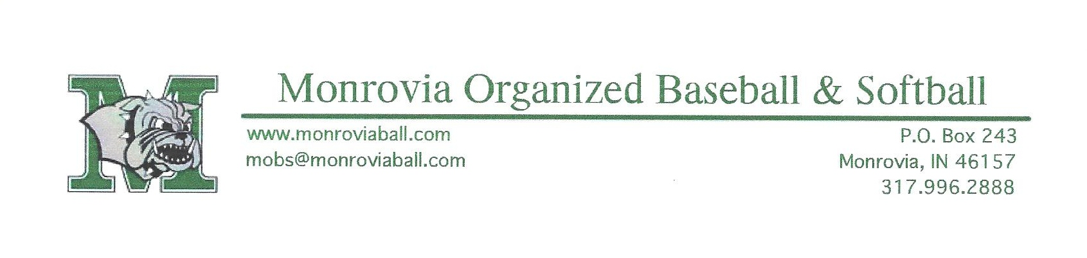
Potential MOBS Partner,
Thank you for your interest in helping the Monrovia Organized Baseball and Softball League. Many of the day to day operations of running a fully functional baseball league require monetary resources that cannot simply be covered by player registrations and fundraisers. This is where we are asking for your assistance.
Below is an outline of our sponsorship levels. We believe the cost of sponsorship can add exposure for your business to other teams from Cloverdale, Amo, Belleville, Bainbridge, Greencastle and more. Additionally, MOBS hosts All-Star tournaments with teams coming from as far away as Connersville.
Please take some time to review the available sponsorships. We can also cater any level to your specific business need.
Single -$100 per field, banner supplied by sponsor, hung on outfield fence for season (April 1- August 15)
Double -$160 per field with league supplied banner, hung on outfield fence for season (April 1- August 15)
Triple- $350 per team with travelling banner for home and away games (banner supplied by sponsor)
Home Run -$410 per team sponsor with league supplied banner travelling banner for home and away games
The Hot Dog -$500 sponsor supplied banner to be placed on concession stand high traffic area
Groundskeeper - $1,000 decal graphics to go on league grounds equipment (i.e., John Deere Gator, concession stand golf cart)
Round Tripper Sponsor -$2,500 tournament named after sponsor with sponsor
Dugout Sponsor - $1500 company name and logo on diamond #3 dugout (2 available)
Bull Pen Sponsor - $50 donation to general scholarship fund (new for 2013)
Popcorn - $100 for booth space during opening day
Roundtripper- $10,000 company name and logo painted on the concession stand facing State Rd 39.
If you have any questions about sponsorship, please feel free to contact any board member.
Thank you for your interest in assisting the youth of our community!

